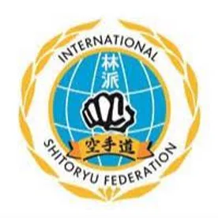
To Whom It May Concern,
We are the International Shito-Ryu Federation of California, a karate school located in Oroville, CA. We invite ambitious local businesses each and every year to sponsor our dojo. We believe that sponsoring our students will be an exceptional form of marketing for your business. We have many families involved in our dojo, and we are always reaching out to the local communities in an effort to bring in more students. As a result, we have new students joining on a near weekly basis. We attend several tournaments a year, usually located in between the Oroville and Sacramento areas. In other words, this means your business is going to have the perfect brand exposure opportunity in front of thousands of people and will have a great impression on people in the local area. Here are the annual sponsorship packages available:
- Bronze: $500 Your company name and logo will be added to the dojo website and social media pages, as well as a picture of our students to hang on your wall showing community support.
- Silver: $1000 Your company name and logo will be added to the dojo t-shirt worn by our students and families, as well as your logo on the banner taken to karate tournaments and parades all over the state.
- Gold: $1250 Your company name and logo will be added to the dojo t-shirts, banner, website, and social media pages.
Donations are always appreciated as well. Any donation of $100 or more will receive a picture of our admired dojo students to hang in your office as well as a signed thank you card from the students.
By sponsoring the International Shito-Ryu Federation of California, your corporation will get amazing promotional perks and benefits. We would therefore ask you to consider this opportunity to become a part of our exciting journey. Funds from sponsorships and donations will help us manage the cost of uniforms, training equipment, travel expenses, and tuition scholarships for players who can’t afford money to practice.
Kindly contact us directly at 530-712-1217 or email I.S.R.F.C.Dojo@gmail.com if you have any questions or seek any more details regarding anything.
Thank you for your time and consideration.
The International Shito-Ryu Federation of California

If you would prefer to give via Venmo, please do so using the code below.
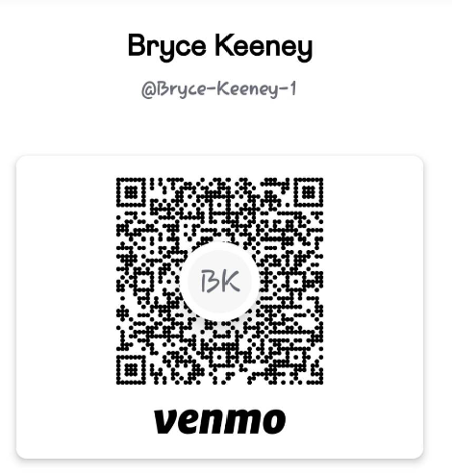
Checks may be sent to:
International Shito-ryu Federation of California
4460 Seacrest Dr
Oroville, CA 95966
Please cut on the line below and send with your payment and a copy of your preferred logo. Thank you for your support!

Company Name: ___________________________________________________________
Address: _________________________________________________________________
Contact Name and Phone/Email:______________________________________________________________
Donation Amount: __________________________________________________________

